WEEK-2
Program 1: Develop and demonstrate the usage of Inline, Internal and External style sheet using CSS

Code:
File: inline_home.html

<!DOCTYPE html>

<html>

<head>

<meta charset="utf-8">

<title>Online Hostel Management</title>

</head>

<body style="margin:0;font-family:Arial;background-image:linear-gradient(rgba(0,0,0,0.6),rgba(0,0,0,0.6)),url('https://images.unsplash.com/photo-1555854877-bab0e564b8d5');background-size:cover;background-position:center;color:white;">

<div style="display:flex;align-items:center;justify-content:space-between;background:rgba(0,0,0,0.8);padding:15px 40px;">

<div style="display:flex;align-items:center;">

<img src="logo.png" style="width:70px;height:auto;">

</div>

<h1 style="margin:0;text-align:center;flex:1;">Online Hostel Management</h1>

<ul style="display:flex;list-style:none;gap:20px;margin:0;">

<li><a href="#" style="color:white;text-decoration:none;">Home</a></li>

<li><a href="#" style="color:white;text-decoration:none;">Login</a></li>

<li><a href="#" style="color:white;text-decoration:none;">Register</a></li>

<li><a href="#" style="color:white;text-decoration:none;">Contact</a></li>

</ul>

</div>

</body>

</html>

File: internal_home.html
<!DOCTYPE html>
<html>
<head>
<meta charset="utf-8">
<title>Online Hostel Management</title>
<style>
body{
margin:0;
font-family:Arial;
background-image:linear-gradient(rgba(0,0,0,0.6),rgba(0,0,0,0.6)),
url("https://images.unsplash.com/photo-1555854877-bab0e564b8d5");
background-size:cover;
background-position:center;
color:white;
}
.navbar{
display:flex;
align-items:center;
justify-content:space-between;
background:rgba(0,0,0,0.8);
padding:15px 40px;
}
.logo{
width:70px;
height:auto;
}
.title{
text-align:center;
flex:1;
}

.menu{
display:flex;
list-style:none;
gap:20px;
}
.menu a{
color:white;
text-decoration:none;
}
</style>
</head>
<body>
<div class="navbar">
<img src="logo.png" class="logo">
<h1 class="title">Online Hostel Management</h1>
<ul class="menu">
<li><a href="#">Home</a></li>
<li><a href="#">Login</a></li>
<li><a href="#">Register</a></li>
<li><a href="#">Contact</a></li>
</ul>
</div>
</body>
</html>

External CSS:

1: external.html

<!DOCTYPE html>

<html>

<head>

<meta charset="utf-8">

<title>Online Hostel Management</title>

<link rel="stylesheet" href="style.css">

</head>

<body>

<div class="navbar">

<img src="logo.png" class="logo">

<h1 class="title">Online Hostel Management</h1>

<ul class="menu">

<li><a href="#">Home</a></li>

<li><a href="#">Login</a></li>

<li><a href="#">Register</a></li>

<li><a href="#">Contact</a></li>

</ul>

</div>

</body>

</html>

File 2: style.css
body{
margin:0;
font-family:Arial;
background-image:linear-gradient(rgba(0,0,0,0.6),rgba(0,0,0,0.6)),
url("https://images.unsplash.com/photo-1555854877-bab0e564b8d5");
background-size:cover;
background-position:center;
color:white;
}
.navbar{
display:flex;
align-items:center;
justify-content:space-between;
background:rgba(0,0,0,0.8);
padding:15px 40px;
}
.logo{
width:70px;
height:auto;
}
.title{
text-align:center;
flex:1;
}
.menu{
display:flex;
list-style:none;
gap:20px;
}
.menu a{
color:white;
text-decoration:none;
}
Output: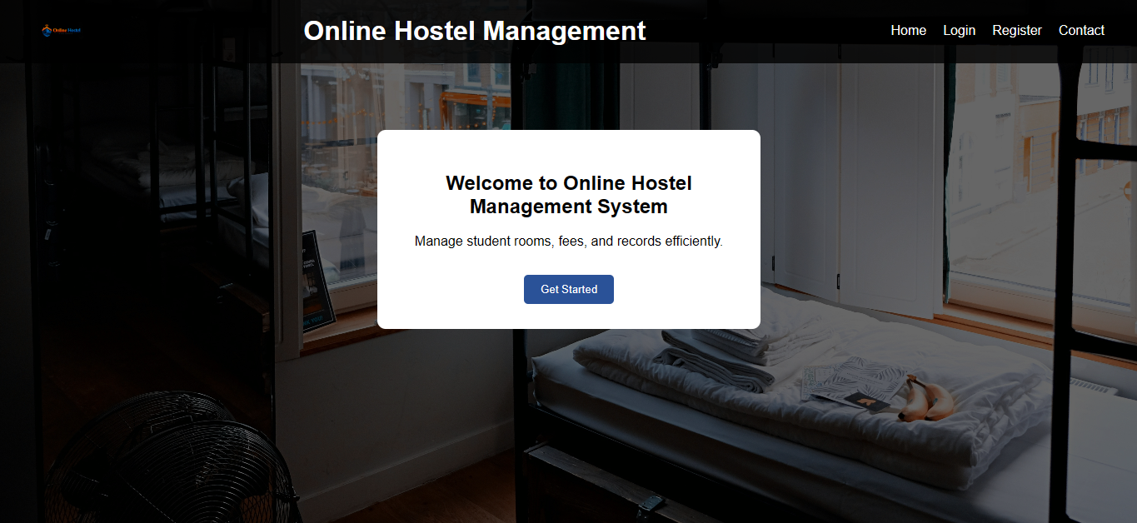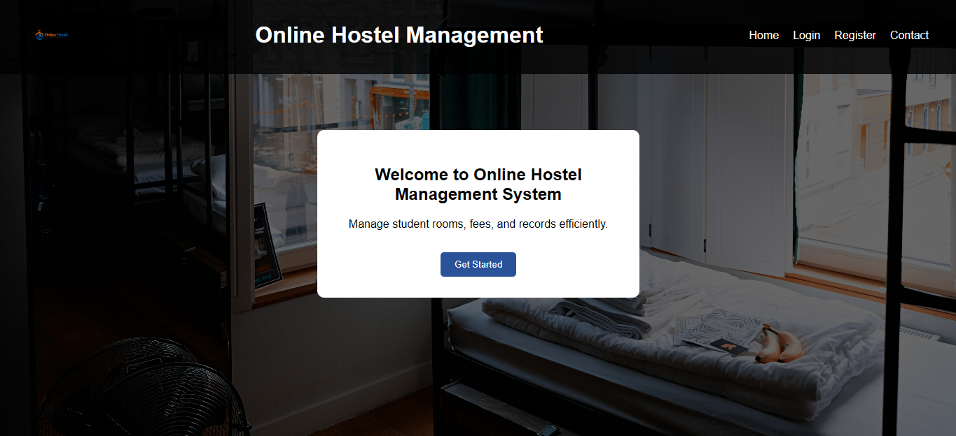
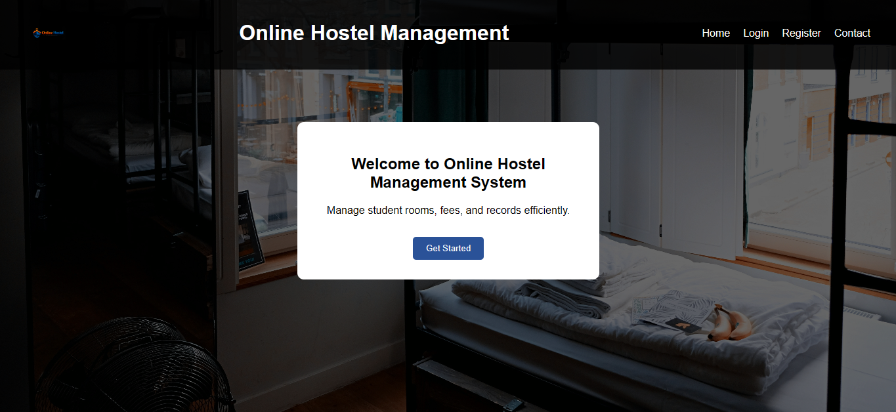
Result :Thus, Inline, Internal and External stylesheets were implemented and demonstrated successfully using CSS.
Program 2: Design a Online hostel mangament Web Page Using CSS Keyframe Animation
Code:
<!DOCTYPE html>
<html>
<head>
<meta charset="utf-8">
<title>Online Hostel Management - Student Record</title>
<style>
/* ===== BODY BACKGROUND IMAGE ===== */
body{
font-family: Arial, sans-serif;
background-image:
linear-gradient(rgba(0,0,0,0.6), rgba(0,0,0,0.6)),
url("https://images.unsplash.com/photo-1505693416388-ac5ce068fe85");
background-size:cover;
background-position:center;
background-repeat:no-repeat;
display:flex;
justify-content:center;
align-items:center;
height:100vh;
margin:0;
}
/* ===== MAIN CARD ===== */
.card{
width:480px;
padding:25px;
background:rgba(255,255,255,0.95);
border-radius:15px;
box-shadow:0px 12px 30px rgba(0,0,0,0.5);
animation:slideIn 1.2s ease-out;
transition:0.3s;
}
.card:hover{
transform:scale(1.03);
}
/* ===== TITLE ===== */
h2{
text-align:center;
color:#0a2a66;
animation:glowText 2s infinite alternate;
}
/* ===== TABLE ===== */
table{
width:100%;
margin-top:20px;
border-collapse:collapse;
}
td{
padding:12px;
border-bottom:1px solid #ddd;
}
/* ===== LABEL ===== */
.label{
font-weight:bold;
background:#e8eeff;
width:40%;
}
/* ===== HOVER ROW EFFECT ===== */
tr:hover{
background:#f5f7ff;
}
/* ===== ANIMATION ===== */
@keyframes slideIn{
from{
transform:translateY(-80px);
opacity:0;
}
to{
transform:translateY(0);
opacity:1;
}
}
@keyframes glowText{
from{
color:#0a2a66;
text-shadow:0 0 5px skyblue;
}
to{
color:#ff4b2b;
text-shadow:0 0 15px orange;
}
}
</style>
</head>
<body>
<div class="card">
<h2>🏠 Hostel Student Record</h2>
<table>
<tr>
<td class="label">Student Name</td>
<td>Kishore Raj</td>
</tr>
<tr>
<td class="label">Register Number</td>
<td>2116241801127</td>
</tr>
<tr>
<td class="label">Course</td>
<td>B.Sc Computer Science</td>
</tr>
<tr>
<td class="label">Hostel Block</td>
<td>Block A</td>
</tr>
<tr>
<td class="label">Room Number</td>
<td>205</td>
</tr>
<tr>
<td class="label">Email</td>
<td>kishore@gmail.com</td>
</tr>
<tr>
<td class="label">Phone</td>
<td>9876543210</td>
</tr>
<tr>
<td class="label">Warden Name</td>
<td>Mr. Rajesh</td>
</tr>
</table>
</div>

</body>
</html>
Web page:
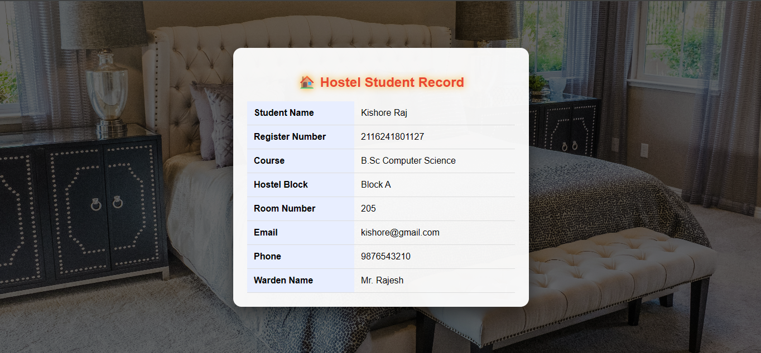

Result :
Thus, Online hostel management Web Page was designed and CSS keyframe animation was implemented successfully.

